**Assignment 1.2**

**Linux commands with Example**

1. **pwd**

|  |  |
| --- | --- |
| Syntax | pwd [OPTION]…  **L, –logical** use PWD from environment, even if it contains symlinks. **-P, –physical** avoid all symlinks. |
| Description | Prints the name of the current working directory. It will print the full system path of the current working directory to standard output. |

Eg:

|  |
| --- |
|  |

1. **vi**

|  |  |
| --- | --- |
| Syntax | To start vi:  **vi filename**  To insert content to the file:  i – insert the text before cursor ,until <Esc> hit.  To exit vi:  :x<Return>quit vi, writing out modified file to file named in original  Invocation   :wq<Return>quit vi, writing out modified file to file named in original invocation  :q<Return>quit (or exit) vi  :q!<Return>quit vi even though latest changes have not been saved for this vi call |
| Description | Vi is a terminal application, an easy-to-use terminal text editor. So we have to start it from a terminal window.  Use **vi /path/to/file** command to open an existing file with Vi.  The **vi /path/to/file** command also work if the file doesn’t exist yet; Vi will create a new file and write it to the specified location when we save. |

**Eg:**

|  |
| --- |
|  |

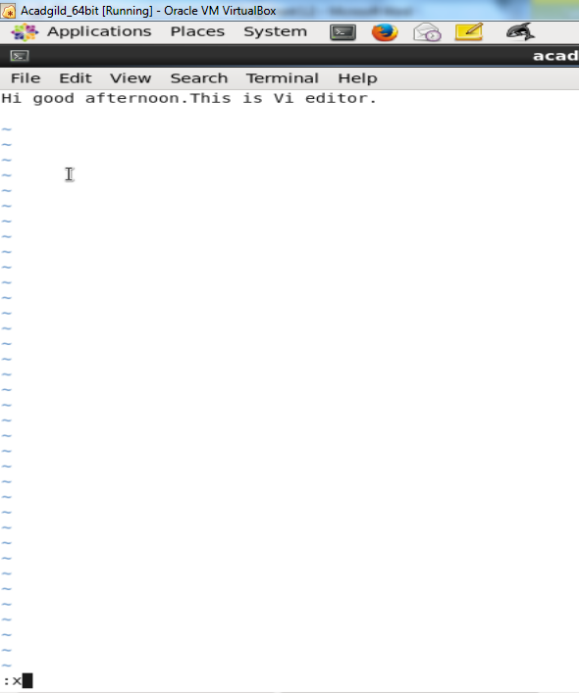

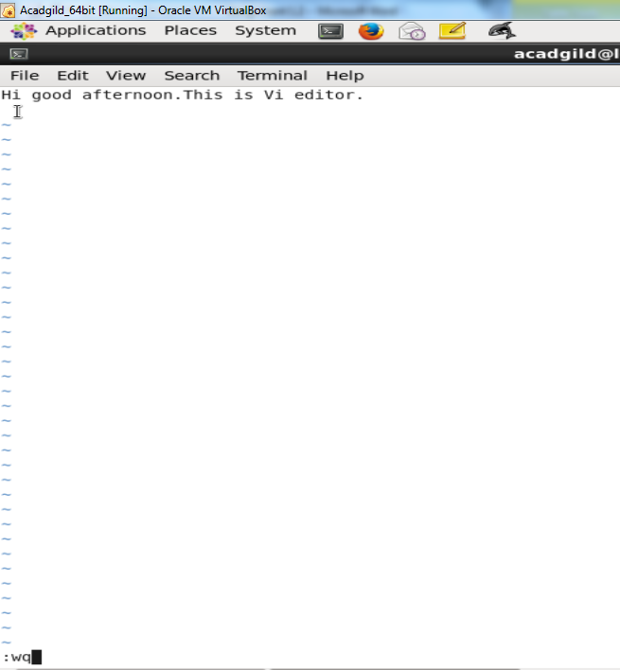

1. **touch**

|  |  |
| --- | --- |
| Syntax | touch [option] file_name(s)  options:   * -a, change the access time only * -c, if the file does not exist, do not create it * -d, update the access and modification times * -m, change the modification time only * -r, use the access and modification times of file * -t, creates a file using a specified time |
| Description | The *touch* command is the easiest way to create new, empty files. It is also used to change the timestamps (i.e., dates and times of the most recent access and modification) on existing files and directories. |

When used without any options, touch creates new files for any file names that are provided as arguments (i.e., input data) if files with such names do not already exist. Touch can create any number of files simultaneously.

For eg, following command create three new empty files named file1,file2 and file3.

touch file1 file2 file3

|  |
| --- |
|  |

1. **mkdir**

|  |  |
| --- | --- |
| Syntax | mkdir [option..] directory … |
| Description | The mkdir command in UNIX allows users to create directories or folders. mkdir command can create multiple directories at once and also set permissions when creating the directory.  If the specified directory is not already exists, then it creates new directory.  The user running the command must have appropriate permissions on the parent directory to create a directory or will receive a permission denied error. |

**Eg:**

To create a directory in UNIX or Linux using the mkdir command pass the name of directory to the mkdir command.

|  |
| --- |
|  |

1. **rm**

|  |  |
| --- | --- |
| Syntax | rm [option] … File … |
| Description | Removes(deletes) files or directories.  **rm** removes each specified *FILE*. By default, it does not remove directories. |

**Eg:**

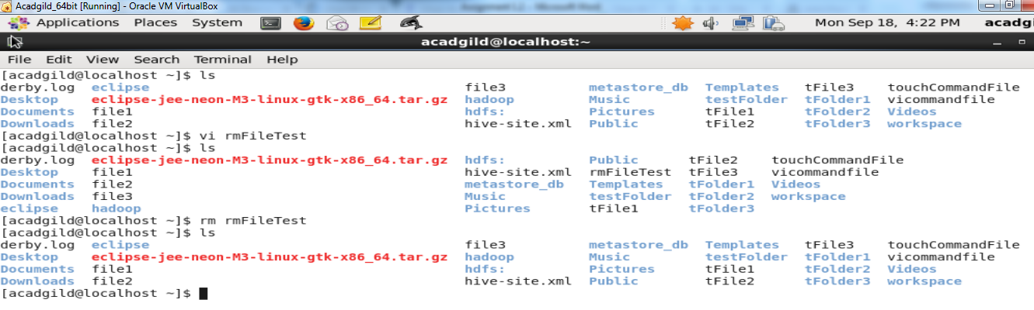

1. **ls**

|  |  |
| --- | --- |
| Syntax | ls [options] [file|directory]  some of the options:  ls –l =list with long format - show permissions  ls –ls = list with long format with file size  ls –r = list in reverse order  ls –a = list all files including hidden file starting with '.'  ls –d = list directories - with ' */' |
| Description | ls is a Linux shell command that lists directory contents of files and directories. |

**Eg:**

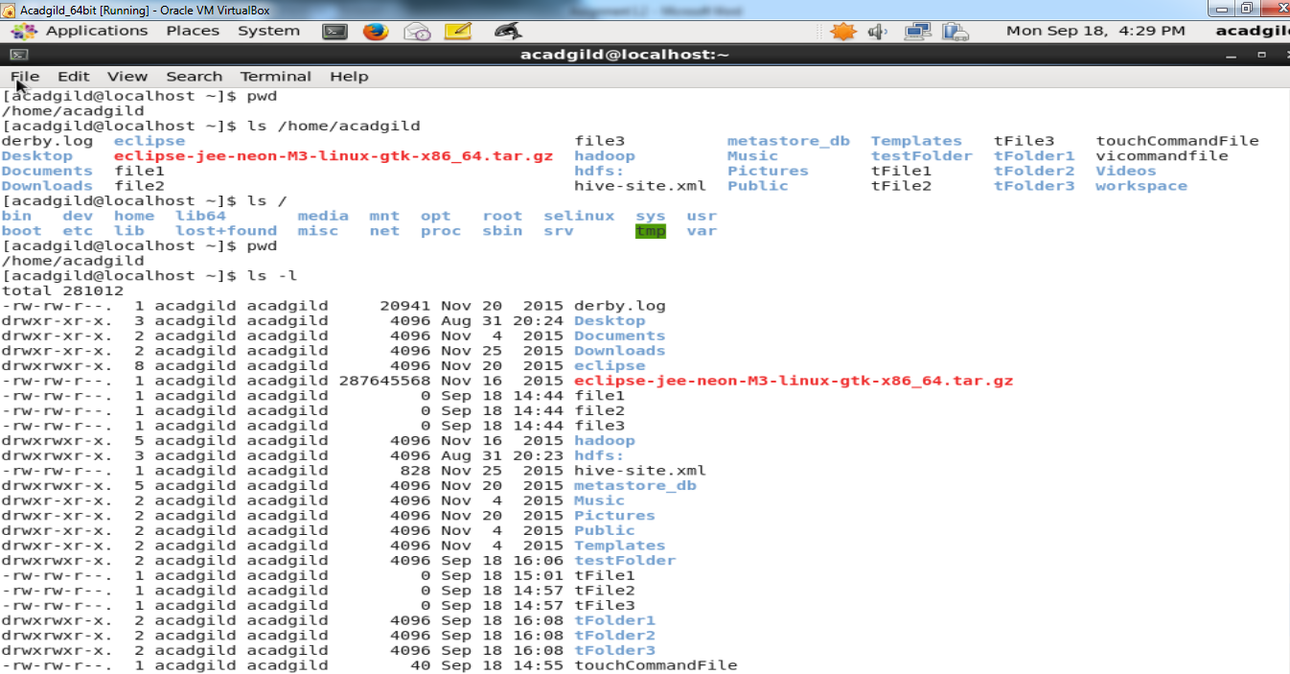

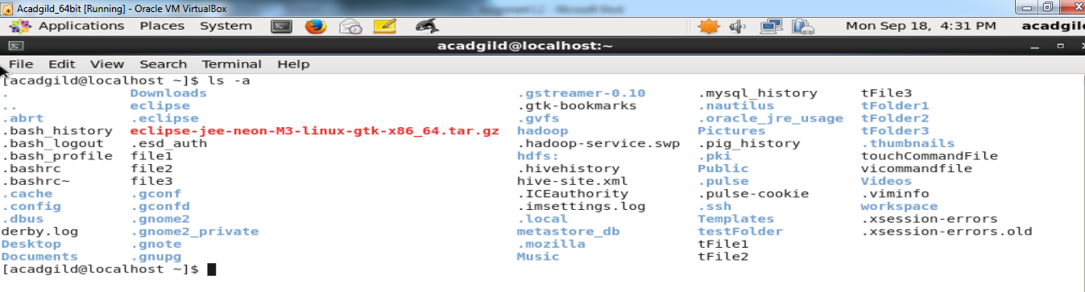

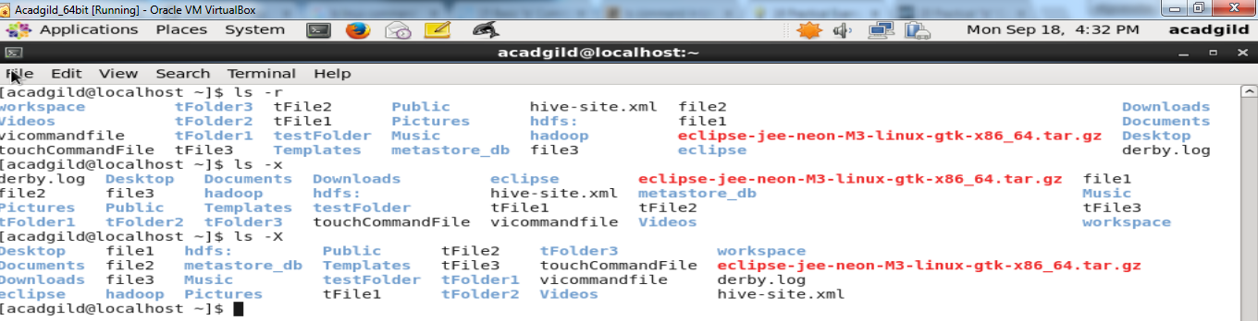

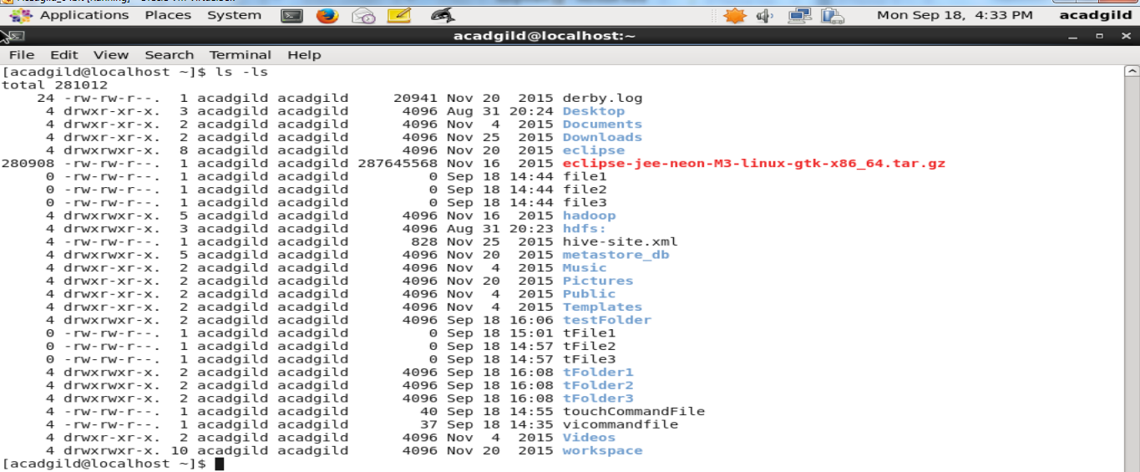

1. **echo**

|  |  |
| --- | --- |
| Syntax | echo [option(s)] [string(s)] |
| Description | Echo command used to display a line of text/string on standard output or a file. |

**Eg:**

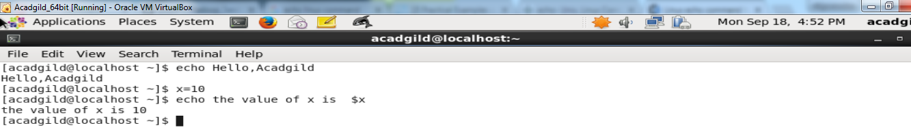

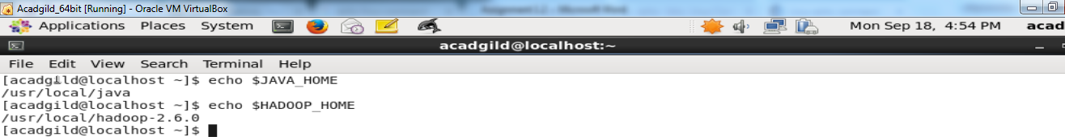

1. **cat**

|  |  |
| --- | --- |
| Syntax | cat [options] [filenames] [-] [filenames] |
| Description | It has three related functions with regard to text files: displaying them, combining copies of them and creating new ones. The most common use of cat is to read the contents of files. |

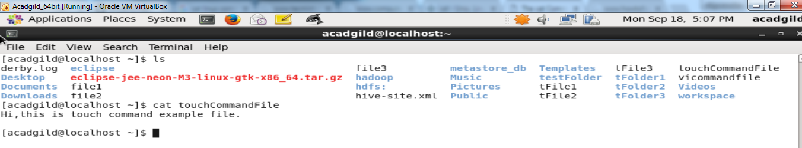

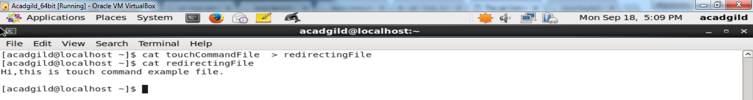

1. **who**

|  |  |
| --- | --- |
| Syntax | **who [option] … [File | arg1 arg2 ]**  who who am i who [options] [File] who --help who --version who | grep 'userNameHere'  **-a**, **--all**  **-b**, **--boot =** time of last system boot  **-d**, **--dead =** print dead processes  **-H**, **--heading =** print line of column headings |
| Description | It displays currently logged in user. Shows who is logged on. |

**Eg:**

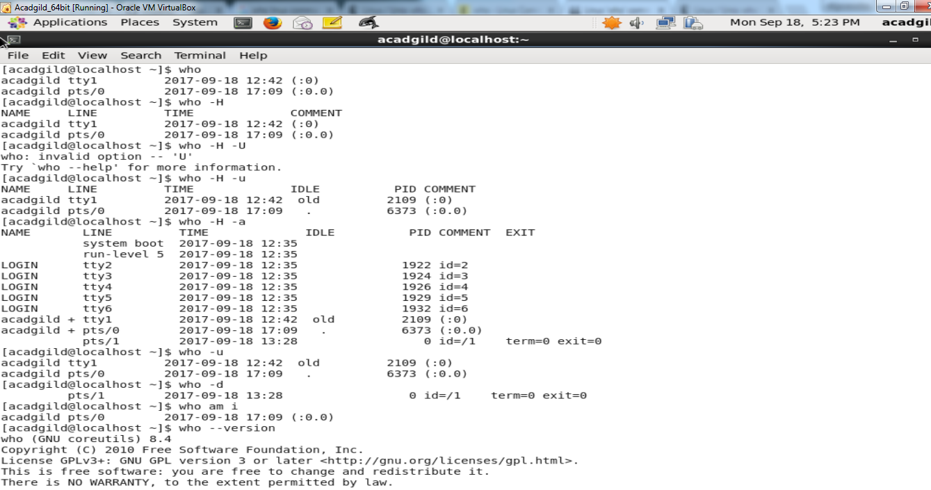

1. **cd**

|  |  |
| --- | --- |
| Syntax | cd directory |
| Description | cd is a Linux command to change the directory/folder of the terminal's shell. |

**Eg :**

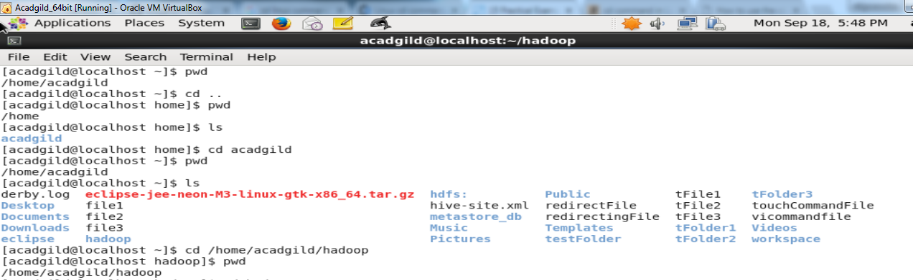

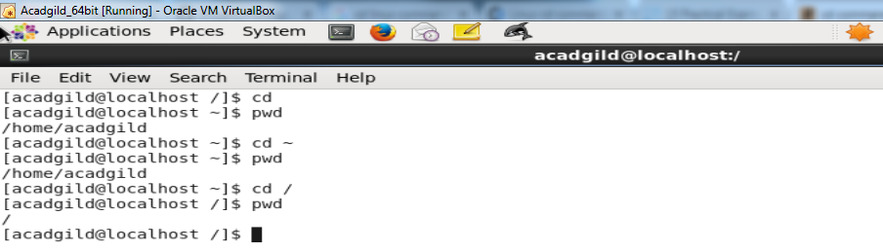

1. **date**

|  |  |
| --- | --- |
| Syntax | **date [option] … [+format]**  **option** :  d, --date=STRING  Display time described by string STRING, as opposed to the default, which is 'now'.  -f, --file=DATEFILE  Like --date, but processed once for each line of file DATEFILE.  **Format:**  FORMAT is a sequence of characters which specifies how output will appear.  %a The abbreviated weekday name (e.g., Sun).  %b The abbreviated month name (e.g., Jan).  %Y Year.  %d Day of month (e.g., 01).  %m Month (01..12).  %w Day of week (0..6); 0 is Sunday.  %I Hour (01..12). |
| Description | It display date in several formats. It also allows to print out, or change the value of, systems date and time.  When you execute date command without any option, it will display the current date and time/ |

|  |
| --- |
|  |

1. **cal**

|  |  |
| --- | --- |
| Syntax | **cal** [**options** ] [[ month ] year ] |
| Description | **Cal** displays a simple calendar. If arguments are not specified, the current month is displayed.  The options are as follows:  **-1** Display single month output. (This is the default.)  **-3** Display prev/current/next month output.  **-s**  Display Sunday as the first day of the week. (This is the default.)  **-m** Display Monday as the first day of the week.  **-j** Display Julian dates (days one-based, numbered from January 1).  **-y** Display a calendar for the current year. |

|  |
| --- |
|  |

1. **mv**

|  |  |
| --- | --- |
| Syntax | mv [options] source dest  **options:**  mv -f = force move by overwriting destination file without prompt  mv -i = interactive prompt before overwrite  mv -u update - move when source is newer than destination  mv -v = verbose - print source and destination files  man mv help manual |
| Description | mv used to move files and directories. |

|  |
| --- |
|  |

1. **which**

|  |  |
| --- | --- |
| Syntax | which [option]  **options:** |
| Description | which command is used to find the location of a program.  Locate the [executable file](https://www.computerhope.com/jargon/e/execfile.htm) associated with a given [command](https://www.computerhope.com/jargon/c/command.htm). |

|  |
| --- |
|  |